***BG-300E***

**Original Operating Instructions**

**Version 1.0**

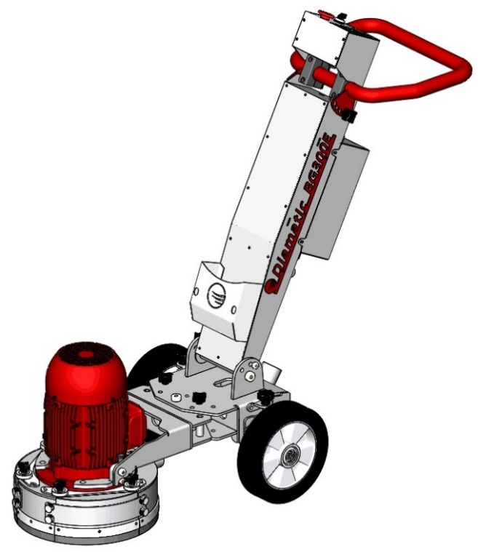



Diamatic

622 Grant Rd

Folcroft, PA 19032

Tel: +1 619-295-0893



Table of Contents

**1. Introduction 3**

**2. Machine Description 3**

**3. Safety 3**

**4. Operating 4**

**5. Maintenance 6**

**6. Settings Frequency Invertor 7**

**7. Technical Data 8**

**8. Spare Parts 9**

8.1 BG-300E upper 9

Table 8.1: BG-300E upper 10

8.2 BG-300E wheel rack unit 11

Table 8.2: BG-300E wheel rack unit 12

8.3 BG-300E grinding head unit 13

Table 8.3: BG-300E grinding head unit 14

8.4 GE0005 Grinder disc unit 15

Table 8.4: GE0005 Grinder disc unit 16

**Electrical Schematic 17**

230 V 60HZ Single Phase Wiring Schematic 17

**Warranty--------------------------------------------------------------------------------------------------------------------------- 18**

# **1. Introduction**

It is important that all persons who are working or maintaining with this machine will read the manual carefully and understand it fully. Keep this manual near the machine, so it can always be consulted.

Only authorized and trained personnel may operate this machine.

# **2. Machine Description**

The BG-300E is an electric driven floor grinding machine for treating horizontal surfaces, especially for edge grinding.

* Closed circuit which is almost dust free, when connected to an appropriate Diamatic dust collector.
* Single-head grinding machine for processing work area edges and corners.
* To be used with standard cup wheel and Ring polishing pad 180 mm.
* Can do grinding and polishing both, Easy to transport, ready to work.
* The grinding arm is vertical adjustable and can be switched to the left or right.
* Grinding head is protected by a rubber buffer, Ergonomic design and user friendly control panel.
* Heavy duty professional equipment 230V, easy to plug in on every jobsite.
* Several optional grinding discs for an optimized use in every specific application.

# **3. Safety**

Before operating the machine, the personnel must be familiar with the safety instructions given in this manual.

Keep this manual near to the machine, so it can always be consulted.

**Safety precautions**

* The surface to be treated must be swept clean to remove stones, screws etc.
* Never use the machine when the surface is not clear and if there is a risk of tripping.
* Make sure there is not any water on the surface to be treated.
* Remove any trailing electrical cables and or dust hoses from the surface to be treated
* Always use a dust collector
* Don’t get disturbed during the activities.

**Safety regulations**

* Persons who are not operating the machine must not be permitted to stay in the surrounding area of the machine.
* Don’t change anything on the machine. Use always cables which are approved and safety earthed (extend) cables. The machine is always equipped with an earthed connection, do not change this and use always earthed cables with an earthed plug.
* Connect main power supply cable to an installation with an earth leakage circuit breaker.
* Inspect and test the electrical components regularly. The electrical components have to satisfy to the requirements which apply to these components.
* Always call a skilled electrician or your distributor when you have questions about the safety of the electrical components.
* Work on electrical equipment or operating materials may only be undertaken by a skilled electrician or by trained persons under the guidance and supervision of a skilled electrician as well as in accordance with the electrical engineering regulations.
* Pull out the main plug during inspections and repairing on the machine.
* Never operate the machine when the surface is wet.
* Never use the machine in the rain.
* The machine contains rotating parts, so always leave the diamond disc on the floor while the motor is turning.
* The flexible coupling can become obsolete with use, because of this there can be higher vibrations than normal. Check for this reason regularly the flexible coupling.

# **4. Operating**

Please read this manual carefully before operating the machine.

1. Adjust the handle to suitable heighten to operate the machine comfortably;
2. Install grinding / polishing tool. Make sure machine is disconnected from power and the E-stop is engaged. Placing the machine into a zero mechanical state. BG-300E is equipped with 2 types of adapter plate, one is with magnetic buttons for installing diamond wings for grinding, and another is with Velcro for connecting resin pads for polishing.

In the initial state, adapter plate with Velcro(GE0046) is bolted on adapter plate with magnetic buttons(GE0005.04), see 7.4 spare part list.

1. Connect the dust hose to the port on BMG-300E and the dust collector;
2. Turn on dust collector;
3. To turn on BG-300E. Pull out emergency button, turn on the switch to start the machine.
4. Rotate the potentiometer to adjust the rotation speed of grinding disc. Speed adjustable range is 0 – 1000rpm(2.2kW) / 0 – 1500rpm(4.0kW).
5. 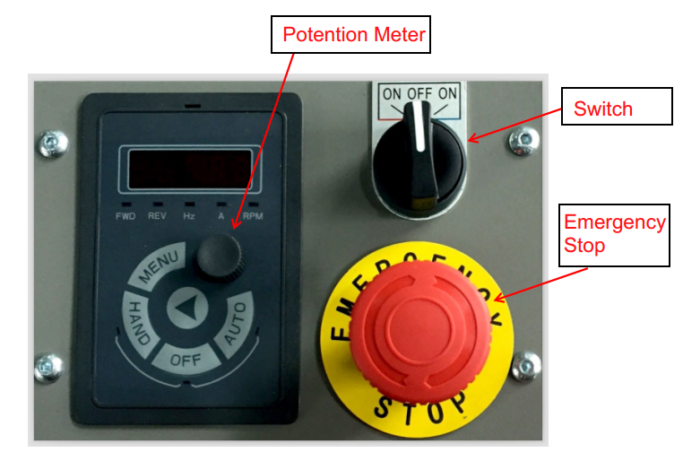Turn off the machine. Press the emergency button to turn off machine

Potentiometer

1. Turn the knob bolt to adjust machine level;
2. Before grinding the wall edge, please adjust the grinding head to left or right as needed.

Take off the knob pins and move the head to left or right, then put the pins back to fix the head.Take off the corresponding side cover.

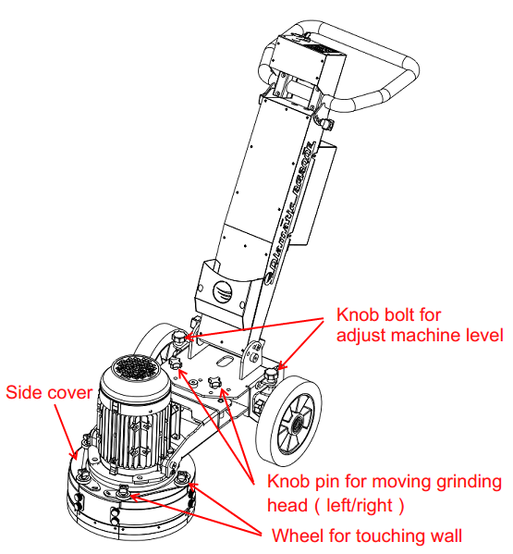

# **5. Maintenance**

Work only with original Diamatic parts.

Check regularly to see if the diamond disc is in good condition. If the diamond disc is damaged or worn out, replace immediately.

Check if the flexible coupling is stiff enough, after every 2 set of diamond wings/resin pad changes. Replace if any deformation or damage is found, replace the coupling after use of 7 diamond discs.

Unusual vibrations on the machine check immediately the diamond disc and flexible coupling

Replacing the flexible coupling:

* Pull out the main plug
* Remove the diamond disc
* Loosen the bolts of the adapter plate and the flexible coupling
* Take a new flexible coupling and assemble this together with the adapter plate on the fixed coupling on the motor axle
* Assemble the brush seal.

Prevent premature wear by keeping the machine as dust free as possible. Clean the machine for this reason regularly with a dust collector

Clean the machine every day with air and non-aggressive materials. Never use a high pressure water cleaner to clean the machine.

Remove the diamond disc after using the machine

Store the cleaned and dry machine in a dry and humid free room. Protect the electrical motor from moisture, heat, dust and shocks.

All repair work must to be done by qualified Diamatic personnel, this to guarantee a safe and reliable machine.

Any guarantee on the machine is expired when:

* Non-original Diamatic parts and diamond discs have been used
* Repair work is not done by qualified Diamatic personnel
* Changes, additions or conversions are undertaken without written permission of Diamatic.

# **6. Settings Frequency Invertor**

Please read the operating manual before setup the frequency invertor.

|  |  |  |  |  |
| --- | --- | --- | --- | --- |
| **Par. No.** | **Name** | **Range** | **Unit** | **Setup** |
| C00.33 | LCP display option | 0~4095 |  | 2 |
| C00.40 | HAND key option | 0：Disabled；1：Enable |  | 1（Default） |
| C00.41 | OFF key option | 0：Disabled；1：Enable；2：Enabled reset only |  | 1 |
| C00.47 | LCP Potentionmeter Step | 0：0.1；1：1；2：10 |  | 1（Default） |
| C01.20 | Motor power | Motor dependant | kW | 2.2 or 4.0 |
| C01.22 | Motor Voltage | 50~1000 | V | 220/230  380/400/440/460 |
| C01.23 | Motor frequency | 20~400 | Hz | 50 or 60 |
| C01.24 | Motor Current | Motor dependant | A | Motor dependant as voltage |
| C01.25 | Motor speed | 100~9999 | rpm | 1000 or 1500 |
| C01.39 | Motor poles | 2~100 | P | 6（2.2kW motor）  4（4.0kW motor） |
| C03.00 | Reference Range | 0: 0 ~ Max；  1：-Max~+Max |  | 1 |
| C03.03 | Maximum reference | 0.000~4999.00 |  | 50 (Default) |
| C03.15 | Reference Source 1 | 0：no function；1：terminal VI；2：terminal AI；8：pulse input DI4；11：local bus；21：LCP potentionmeter |  | 21 |
| C03.41 | Motor speed up time | 0.05~3600.00 | s | 5 |
| C03.42 | Motor speed down time | 0.05~3600.00 | s | 8 |
| C04.16 |  | 0~1000 | % | 1000（Default） |
| C04.17 |  | 0~1000 | % | 1000（Default） |
| C04.18 | Current limit | 0~300 | % | 280 |
| C05.10 | Terminal FOR | 0: no operation；1: reset；6: Stop inverse 9:Latched start；37: Latched reversing |  | 6 |
| C05.12 | Terminal DI1 |  | 9 |
| C05.13 | Terminal DI2 |  | 37 |
| C06.81 | LCP pot. Min. Refer. | -4999.00~4999.00 |  | -50 |
| C14.18 | Delay time of Auto Restart When power again | 0~3600 | s | 3600 |
| C14.22 | Operation mode | 0：normal operation；2：Initialization；3：Backing user settings；4：Recover user settings |  | Dependant |

# **7. Technical Data**

|  |  |  |
| --- | --- | --- |
|  | **BG-300E** | |
| **Motor power** | **2.2 kW –three phase** | **4.0kW** |
| **Power supply** | **230V single phase** | **230V，400V，460V，50/60Hz, three phase** |
| **Adapter Disc** | **Ø 300mm** | |
| **Disc speed** | **0-1000rpm adjustable** | **0-1500rpm adjustable** |
| **Length** | **130 cm** | |
| **Width** | **45cm** | |
| **Height** | **110 cm** | |
| **Weight** | **85 kg** | **90kg** |

Design and specifications are subject to change without notice by Diamatic.

# **8. Spare Parts**

## 8.1 BG-300E upper

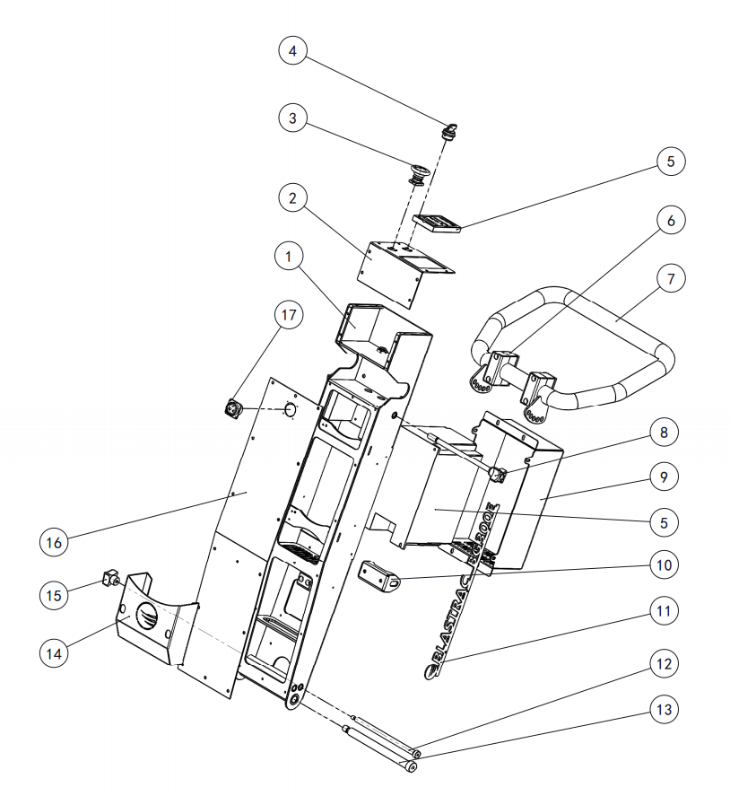

## Table 8.1: BG-300E upper

|  |  |  |  |
| --- | --- | --- | --- |
| **No.** | **Item number** | **Description** | **QTY** |
| 1 | GE0006 | Steer handle | 1 |
| 2 | GE0013 | Control top plate | 1 |
| 3 | ME0310 | Emergency stop switch | 1 |
| 4 | ME0311 | Switch | 1 |
| 5 | GE0051 | Frequency invertor 3x380V-460V | 1 |
| GE0065 | Frequency invertor 1x220V | 1 |
| GE0068 | Frequency invertor 3x220V-240V | 1 |
| 6 | ME0209 | Pipe clamp | 2 |
| 7 | GE0007 | Handle weldment | 1 |
| 8 | GE0030 | JB 7247.3-1994 M10 | 2 |
| Stud bolt GB/T 953-1988 M10X220-Q | Stud bolt long | 1 |
| 9 | GE0016 | Control box | 1 |
| 10 | GE0045 | Swing arm | 1 |
| 11 | GE0010  GE0068 | Logo Diamatic BG-300E  Logo Diamatic BG-300E | 2 |
| 12 | bolt GB/T 5281-1985 D10X185 | Shoulder bolt | 1 |
| 13 | bolt GB/T 5281-1985 D16X185 | Shoulder bolt | 1 |
| 14 | GE0059 | Tool box | 1 |
| 15 |  | Nut JB 7247.3-1994 M8 | 1 |
| 16 | GE0021 | Socket mounting plate | 1 |
| 17 | GE0039 | Connector 220V male | 1 |
| GE0040 | Connector 220V female | 1 |

## 8.2 BG-300E wheel rack unit

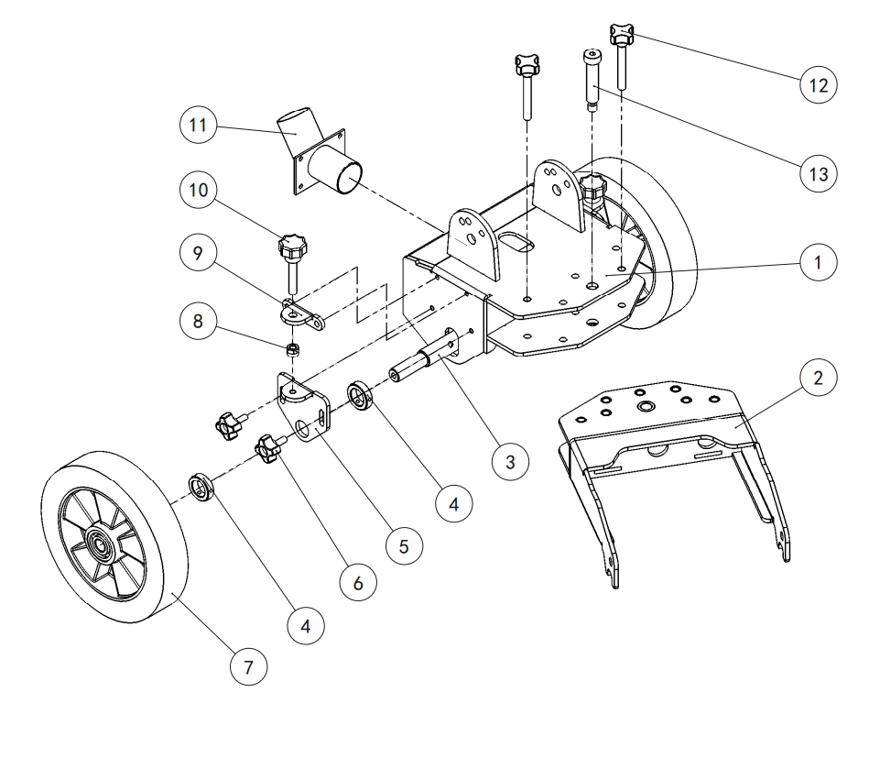

## Table 8.2: BG-300E wheel rack unit

|  |  |  |  |
| --- | --- | --- | --- |
| **No.** | **Item number** | **Description** | **QTY** |
| 1 | GE0001 | Upper frame | 1 |
| 2 | GE0002 | Frame | 1 |
| 3 | GE0012 | Wheel axle | 1 |
| 4 | GE0011 | Wheel axle sleeve | 4 |
| 5 | GE0018 | Wheel height adjustment plate | 2 |
| 6 | GE0037 | Star bolt M8x20 | 4 |
| 7 | 980110 | Wheel 250x50x（60） | 2 |
| 8 | Nut GB/T6128-2000 M8 | Nut | 2 |
| 9 | GE0019 | Wheel height adjustment fixing plate | 2 |
| 10 | GE0034 | Star knob bolt M10x60 | 2 |
| 11 | GE0009 | Dust pipe | 1 |
| 12 | E03550 | Locking pin compl. | 2 |
| 13 | Bolt GB/T 5281-1985 D16X70 | Shoulder bolt | 1 |

## 8.3 BG-300E grinding head unit

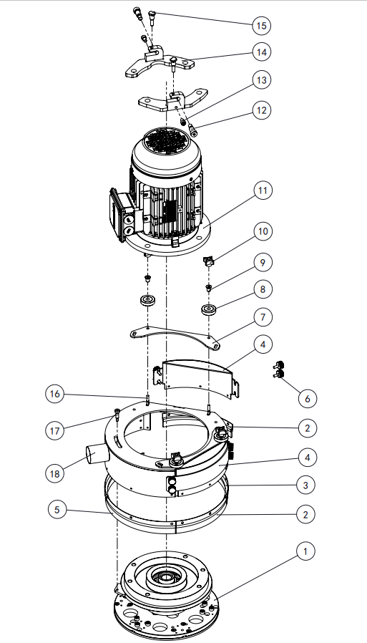

## Table 8.3: BG-300E grinding head unit

|  |  |  |  |
| --- | --- | --- | --- |
| **No.** | **Item number** | **Description** | **QTY** |
| 1 | GE0005 | Grinder disc unit | 1 |
| 2 | GE0036 | Brush flex part 03 | 2 |
| 3 | GE0028 | Brush flex part 02 | 1 |
| 4 | GE0008 | Cover side | 2 |
| 5 | GE0027 | Brush flex part 01 | 1 |
| 6 | bolt GB/T 834-1988 M6x16 | bolt | 4 |
| 7 | GE0017 | Roller mounting plate | 2 |
| 8 | GE0038 | Bearing Ф10xФ40x10 | 4 |
| 9 | GE0015 | Bearing sleeve | 4 |
| 10 | GE0029 | Star bolt JB 7247.3-1994 M6 | 4 |
| 11 | GE0048-1 | Motor 2.2kW-100L-6P 230V/400V/460V | 1 |
| GE0070-1 | Motor 4.0kW-100L-4P-B5T-IE2  400V 50Hz | 1 |
| GE0070-2 | Motor 4.0kW-100L-4P-B5T-IE2  230V/460V 60Hz | 1 |
| 12 | bolt GB/T 5281-1985 D13X20 | Shoulder bolt | 2 |
| 13 | bolt GB/T 70.1-2000 M8X10 | bolt | 2 |
| 14 | GE0003 | Upper coupling | 1 |
| 15 | GE0020 | Disc knob | 2 |
| 16 | bolt GB/T 12-1988 M6X35 | Bolt | 4 |
| 17 | bolt GB/T 5281-1985 D8X25 | Shoulder bolt | 1 |
| 18 | CNP/GE0004 | Housing | 1 |

## 8.4 GE0005 Grinder disc unit

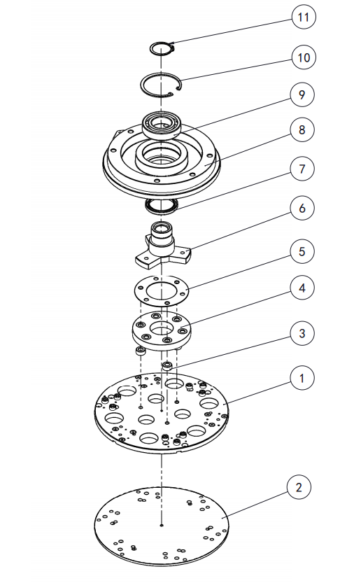

## Table 8.4: GE0005 Grinder disc unit

|  |  |  |  |
| --- | --- | --- | --- |
| **No.** | **Item number** | **Description** | **QTY** |
| 1 | GE0005.04 | Adapter plate for wings | 1 |
| 2 | GE0046 | Adapter D300 with Velcro  backing | 1 |
| 3 | E03250 | Spacer ring | 3 |
| 4 | 0001182 | Flexible coupling | 1 |
| 5 | GE0014 | Plate | 1 |
| 6 | GE0005.01 | Shaft unit | 1 |
| 7 | GE0024 | Oil seal 55x72x8 | 1 |
| 8 | GE0005.03 | Bearing house | 1 |
| 9 | GE0022 | Bearing | 1 |
| 10 | GB/T 893.1-1986 85 | inner retaining clip | 1 |
| 11 | GB/T 894.1-1986 45 | outer retaining clip | 1 |

# **Electrical Schematic**

## 230 V 60HZ Single Phase Wiring Schematic



DIAMATIC®

**PRODUCT WARRANTY**

**STANDARD EQUIPMENT PRODUCTS**

Diamatic warrants its ***DIAMATIC*** standard equipment products against defects in material and workmanship under normal and proper use for a period of **2 years** from the date of delivery or, in the case of Rental Fleet Machines, 180 days from the date of assignment to a Rental Fleet. Diamatic makes this warranty only to the buyer who purchases the products directly from Diamatic or its authorized distributor. This warranty does not include expendable parts such as, but not limited to, diamonds, wear parts, couplers, and diamond plates.

**The buyer must register the product with the warranty card. This warranty card must be mailed to Diamatic within 45 days after taking delivery of the Diamatic machine to receive full warranty. Any machine not registered under warranty through Diamatic will only receive a 6 month warranty period from the date of delivery.**

**Warranty Terms and Conditions:**

1. Diamatic’s obligation under this warranty is limited to the replacement or repair, at Diamatic’s option, of products and does not include, labor, the cost of transportation, loss of operating time, or normal maintenance services.
2. This warranty does not apply to failure occurring as a result of abuse, misuse, negligence, corrosion, erosion, normal wear and tear, alterations or modifications made to products without express written consent of Diamatic.
3. The buyer must submit all warranty claims no later than thirty (30) days after buyer becomes aware of the basis for any such claim, or should have become aware of the basis for any such claim in the exercise of reasonable diligence.

To return parts for warranty consideration, please call Diamatic Customer Service at ***866-295-5512***.

Our customer service representative will obtain the necessary information to complete the Diamatic Returned Merchandise Authorization (RMA) Form. Diamatic will then send the RMA form to the customer authorizing the return of the parts for warranty evaluation.

The parts must be received within sixty (60) days following the RMA origination date or the warranty claim will be denied. Once the parts are received they will be evaluated for warranty.

If the customer cannot wait for the evaluation/replacement of the parts during   
this process, the customer must issue a new purchase order to Diamatic for the replacement parts before they can be shipped. Once the evaluation process is complete and parts are deemed a valid warranty claim, a credit will be issued against this invoice.

1. The buyer may not return Diamatic products without Diamatic’s written authorization to do so.
2. Diamatic reserves the right to inspect and determine the scope of its warranty responsibilities for any returned Diamatic products.
3. Diamatic makes no warranty with respect to accessories it does not manufacture, including but not limited to, engines, motors, batteries, tires and all other parts. See component manufacture warranty.
4. Diamatic reserves the right to make product changes or improvements without prior notice and without undertaking any obligation such changes or improvements on previously sold products.
5. The above warranty conditions can only be altered by Diamatic. Diamatic must confirm alterations in writing for each specific transaction.
6. Diamatic reserves the right to modify this warranty for used or demo products on an individual transaction basis. Diamatic will include warranty modifications on its invoices for used or demo products
7. DIAMATIC DOES NOT AUTHORIZE ANY PERSON, REPRESENTATIVE OR SERVICE OR SALES OUTLET TO MAKE ANY WARRANTY DIFFERENT FROM THIS PRODUCT WARRANTY.
8. EXCEPT FOR ITS PRODUCT REPAIR OR REPLACEMENT OBLGATIONS DESCRIBED IN THIS PRODUCT WARRANTY, UNDER NO CIRCUMSTANCES SHALL DIAMATIC BE LIABLE TO THE BUYER OR ANY OTHER PERSON FOR ANY DIRECT, INCIDENTAL, OR CONSEQUENTIAL DAMAGES RESULTING FROM THE USE OF THE DIAMATIC PRODUCT OR FOR ANY SPECIAL OR CONSEQUENTIAL DAMAGES OF ANY CHARACTER, INCLUDING WITHOUT LIMITATIONS, DAMAGES FOR ANY LOSS OF GOODWILL, WORK STOPPAGE, OR ANY AND ALL OTHER COMMERCIAL DAMAGES OR LOSSES.
9. DIAMATIC MAKES NO OTHER PRODUCT WARRANTIES, EXPRESS OR IMPLIED, INCLUDING, BUT NOT LIMITED TO, THE IMPLIED WARRANTIES OF MERCHANTABILITY AND FITNESS FOR A PARTICULAR PURPOSE.

